Annex 14
Commentary on the Presentation (Annex 13)
Slide 1
Slide 1 presents a conceptual diagram of the algorithm for creating railway electronic documents - equivalents of SMGS consignment notes; CIM and CIM/SMGS in the UN/EDIFACT standard and converting them into appropriate forms of electronic documents in the UN/CEFACT standard (in XML and JSON formats) based on the UN/CEFACT Reference Data Model for Multimodal Transport (MMT - RDM).
This algorithm shows that the rules for creating electronic railway documents in the UN/EDIFACT standard are regulated on OSJD railways by OSJD instructions/memo and joint OSJD/UIC instructions/memo. The main ones are: Instruction O + R 942 - "Technology of information support for freight traffic under SMGS in electronic data interchange in the UN / EDIFACT standard", Instruction O + R 943 - "Library of standard electronic messages for freight traffic in international traffic on the terms of SMGS in the standard UN/EDIFACT" and Instruction O + R 944 - "List of classifiers and codes of data elements. Library of code lists for freight traffic on the terms of SMGS".
Guided by these instructions, electronic SMGS consignment notes are formed; CIM and CIM/SMGS in the form of message IFTMIN 97A - Electronic message about the dispatch of goods (formation of a transport dossier for transportation) for the railway waybill. This message has been adapted by Edifer Bureau for use in rail transport.
The UN/CEFACT Reference Data Model for Multimodal Transport (MMT-RDM) is used to convert the IFTMIN 97A message into a UN/CEFACT electronic document form (in XML and JSON formats). Thus MMT-RDM can be used as a converter for converting UN/EDIFACT railway electronic documents into UN/CEFACT electronic documents (in XML and JSON formats) and vice versa.
Slides 2 - 5 show how this transformation is implemented using the example of matching data from the forms of standard railway waybills (SMGS, CIM and CIM / SMGS) with data from the electronic equivalents of these documents in the UN / EDIFACT standard (in the IFTMIN 97A message format) and in UN/CEFACT standard (in XML and JSON formats).

Slide 2
The second slide shows a diagram of how the existing data pipeline model and guidance material for data exchange across UN/CEFACT multimodal digital corridors (https://unece.org/DAM/cefact/Standards/MMT/BRS_T_L-MMTDataElements.xls) is used to determine the path to the rail waybill data - on this slide to the consignor code and the UN dangerous goods code. The data for the consignment code and the UN dangerous goods code are obtained from the MMT RDM description (file - CIM-SMGS Consignment Note.xls) for elements 3039 and 7124 respectively (column TDED).
When using the international directory UN TDED, the unity of names, representations, dimensions and filling order (lists of codes used) is guaranteed for all data elements in existing or developed documents. At the same time, electronic data exchange between participants in foreign economic relations is implemented without difficulty.
Code 3039 corresponds to IFTMIN segment element 3039 - NAD+CZ, code 7124 corresponds to IFTMIN segment element 7124 - DGS+RID from O+P leaflet 943.
Slide 3
The third slide shows the path (link) obtained from MMT RDM, along which data on the consignor code is posted, with reference to the corresponding columns of the SMGS, CIM/SMGS, CIM railway waybills.
Slide 4
The fourth slide shows a scheme for converting electronic documents in the UN/EDIFACT standard into electronic documents of similar content in the new UN/CEFACT standard in XML format using the consignor code as an example.
Based on element 3039 (consignor code) specified in the TDED column of the "CIM-SMGS Consignment Note.xls" file, a description of the NAD segment, its position, group, elements given in the "SMGS-IFTMIN.doc" file was found and the data were compared according to the segment description IFTMIN - NAD memo (instruction) O+R 943
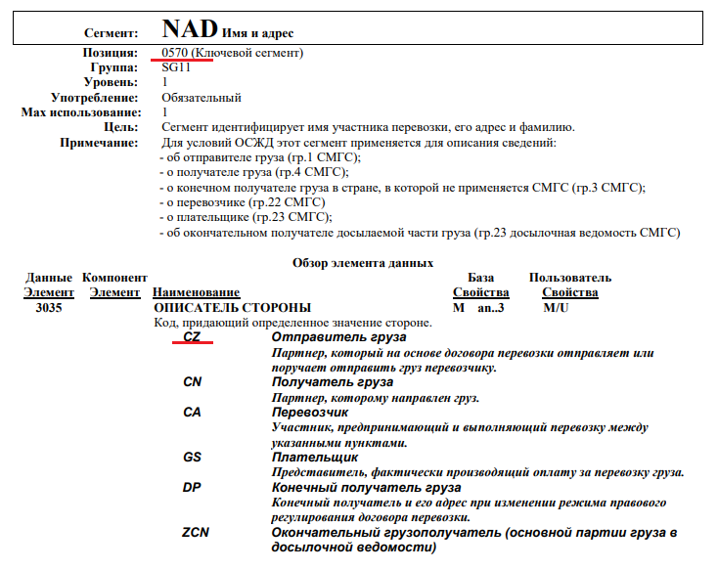
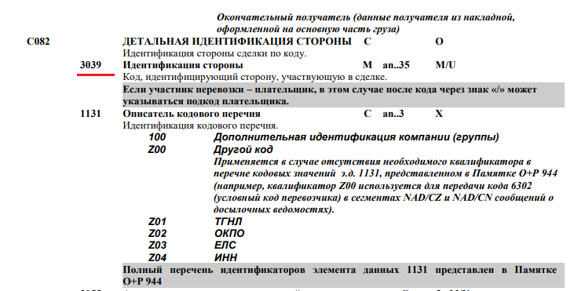
According to the results of the comparison for element X of the NAD segment (Consignor code) -
NAD+CZ+X:Type++ NAME:NAME:NAME: NAME:NAME:LNG+AD+ T5++Y+Z' of the IFTMIN_Mapping.xls file defines the sender code.
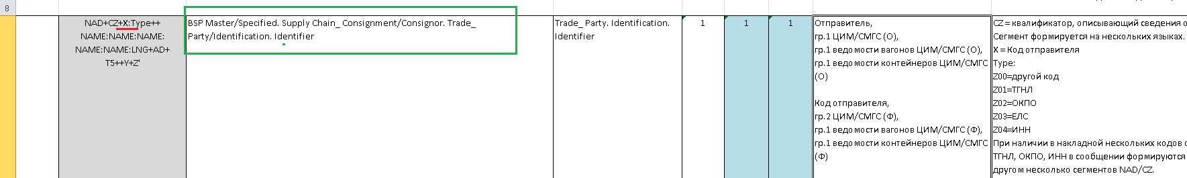

Slide 5
Slide 5 presents a conceptual diagram of a converter for converting UN/EDIFACT electronic equivalents of railway transport documents (SMGS, CIM and CIM/SMGS) into UN/CEFACT electronic documents based on the UN/CEFACT Reference Data Model for Multimodal Transport (MMT - RDM).
For conversion, the description of the correspondence of railway transportation documents to the MMT multimodal transport model is used. Data blocks in the EDIFACT standard correspond to paths in the MMT model.
The task of the converter is to use data from incoming railway transportation documents described by EDIFACT standards and a description of the correspondence of paths in the MMT model to data in the EDIFACT standard to generate a formalized description of these documents in XML and JSON formats in such a way that the structure and the output data blocks would correspond to the tree structure of the MMT data model.
Based on the conceptual diagram presented on the slide, a software converter can be developed that should provide the capability to automatically recode messages from the EDIFACT standard to UN/CEFACT XML messages and vice versa for use between participants of transportation processes, including multimodal transportation.

